- datapath
  - block diagram
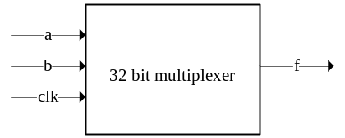
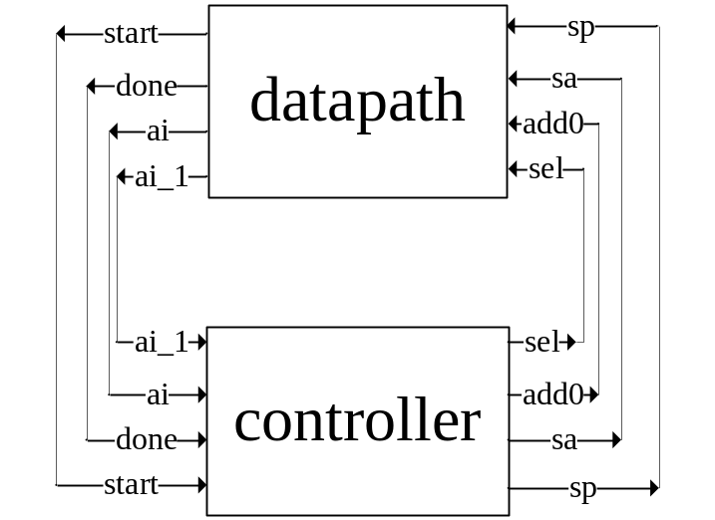

Datapath:

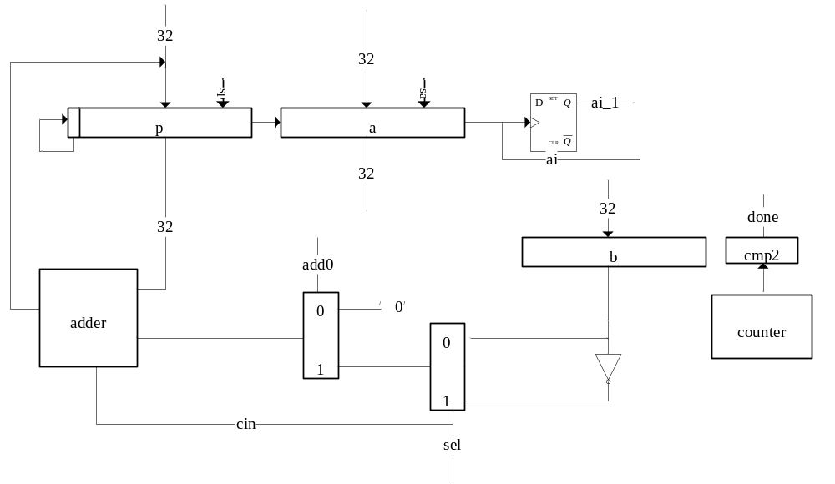
  - ASM chart
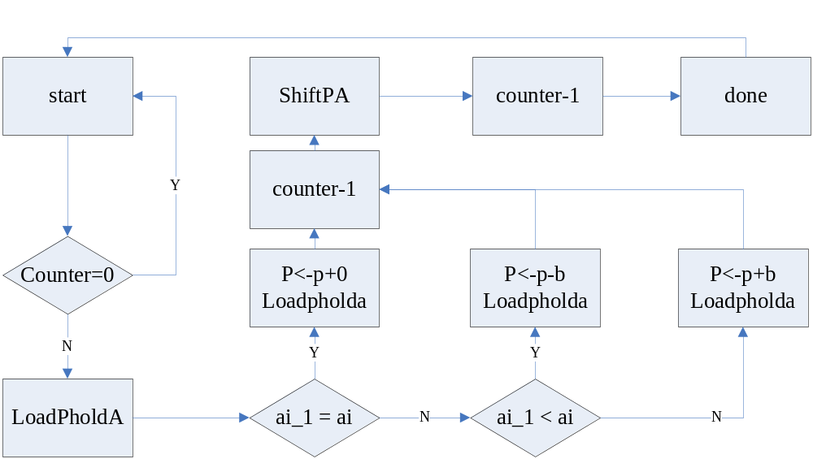
  - State diagram
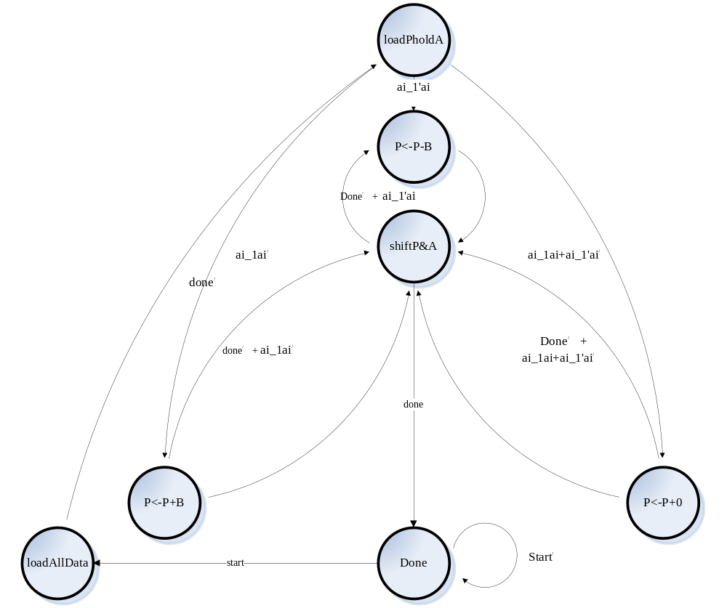
  - Schematics
    - 32 bit adder
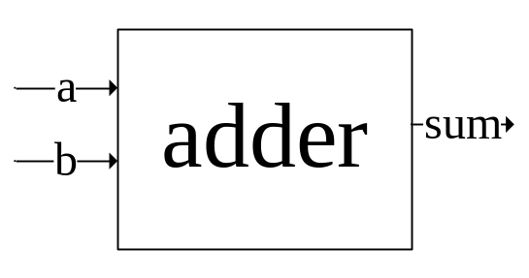
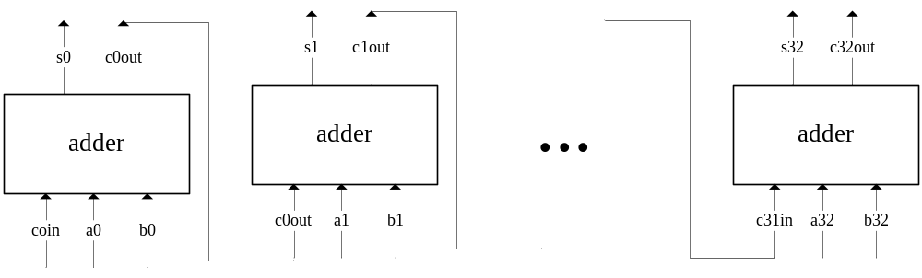code
entity adder_32 is
port(a,b : in bit_vector (31 downto 0);
sum : out bit_vector (31 downto 0));
end entity;

architecture struct of adder_32 is
component full_adder is
port(a,b,cin : in bit;
cout,sum: out bit);
end component;

for all : full_adder use entity work.full_adder(dataflow);

signal c : bit_vector (32 downto 1);
signal carry : bit;

begin
adder : for i in 0 to 31 generate

ls_bit : if i = 0 generate
ls_cell :full_adder port map (a(0), b(0), '0' , c(1),sum(0));
end generate ls_bit;

middle_bit : if i > 0 and i < 31 generate
middle_cell : full_adder port map (a(i), b(i), c(i), c(i+1),sum(i));
end generate middle_bit;

ms_bit : if i = 31 generate
ms_cell : full_adder port map (a(i), b(i), c(i), carry,sum(i));
end generate ms_bit;
end generate adder;
end struct;

testbench
library ieee;
use ieee.std_logic_1164.all;
use work.my_package.all;

entity adder_32_tb is
end entity;

architecture io of adder_32_tb is
component adder_32 is
port(a,b : in bit_vector (31 downto 0);
sum : out bit_vector (31 downto 0));
end component;

for all: adder_32 use entity work.adder_32(struct);

signal a,b,sum : bit_vector (31 downto 0);

begin
c1: adder_32 port map(a,b,sum);
p1: process
variable i,j : integer;
begin
outer_loop: for i in 0 to 10 loop
a <= to_vector(i);
inner_loop: for j in 0 to 10 loop
b <= to_vector(j);
wait for 50 ns;
end loop inner_loop;
end loop outer_loop;
end process p1;
end io;

waveform
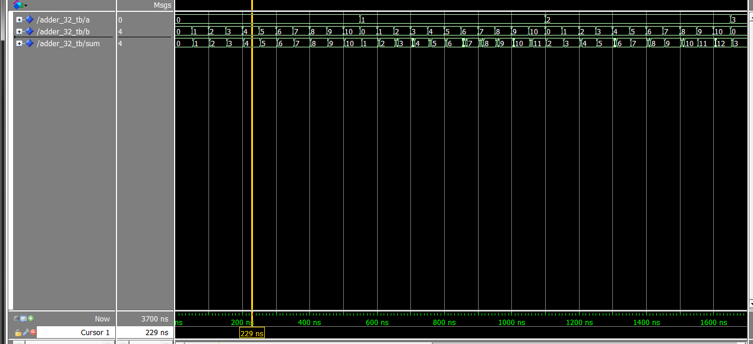

    - 32 bit Shift register
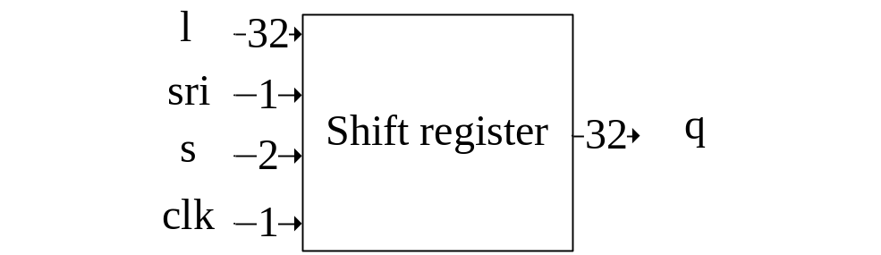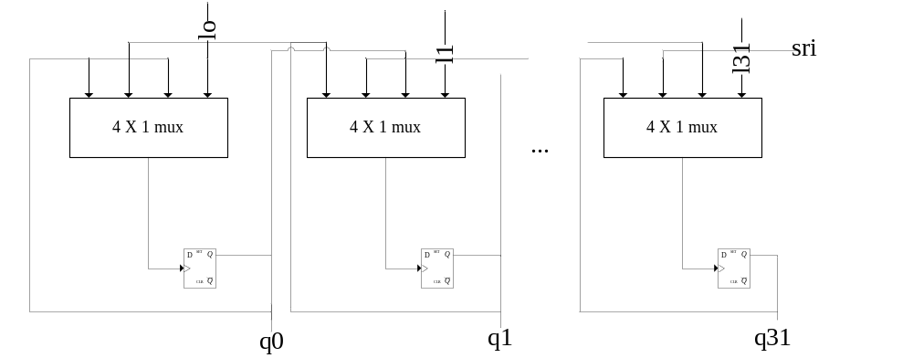code
entity shift_register_32 is
port (l : in bit_vector (31 downto 0);
sli, sri, clk, rstb : in bit;
s : in bit_vector (1 downto 0);
q : out bit_vector (31 downto 0));
end entity;

architecture struct of shift_register_32 is
component mux_4to1 is
port(a,b,c,d : in bit;
s : in bit_vector(1 downto 0);
f : out bit);
end component;

component dff is
port( d,clk,rstb : in bit;
q,not_q : out bit);
end component;

for all : mux_4to1 use entity work.mux_4to1(dataflow);
for all : dff use entity work.dff(dataflow);

signal im_din, im_qs : bit_vector (31 downto 0);

begin
shift_register : for i in 0 to 31 generate

ls_bit : if i = 0 generate
ls_cell :mux_4to1 port map (l(0),im_qs(1),sri,im_qs(0),s, im_din(0));
ls_cell2 : dff port map (im_din(0),clk,rstb,im_qs(0));
q(0) <= im_qs(0);
end generate ls_bit;

middle_bit : if i > 0 and i < 31 generate
middle_cell : mux_4to1 port map (l(i),im_qs(i+1),im_qs(i-1),im_qs(i),s, im_din(i));
middle_cell2 : dff port map (im_din(i),clk,rstb,im_qs(i));
q(i) <= im_qs(i);
end generate middle_bit;

ms_bit : if i = 31 generate
ms_cell : mux_4to1 port map (l(i),sli,im_qs(i-1),im_qs(i),s, im_din(i));
ms_cell2 : dff port map (im_din(i),clk,rstb,im_qs(i));
q(i) <= im_qs(i);
end generate ms_bit;

end generate shift_register;

end struct;

testbench
library ieee;
--use ieee.std_logic_1164.all;
use work.my_package.all;

entity shift_register_32_tb is
end entity;

architecture io of shift_register_32_tb is
component shift_register_32 is
port (l : in bit_vector (31 downto 0);
sli,sri, clk, rstb : in bit;
s : in bit_vector (1 downto 0);
q : out bit_vector (31 downto 0));
end component;

for all: shift_register_32 use entity work.shift_register_32(struct);

signal l, q :bit_vector (31 downto 0);
signal sli,sri, clk, rstb : bit;
signal s : bit_vector(1 downto 0);

begin
c1: shift_register_32 port map(l,sri,clk,rstb,s,q);

l <= "10000000000001000000111000000000";
clk <= not clk after 10ns;
rstb <= '1';
sri <= '1';
s <= "00", "01" after 100ns, "01" after 200ns, "11" after 300ns, "01" after 400ns, "10" after 500ns, "11" after 600ns,"10" after 700ns, "01" after 1220ns ;
sli <= q(31);
end io;

waveform
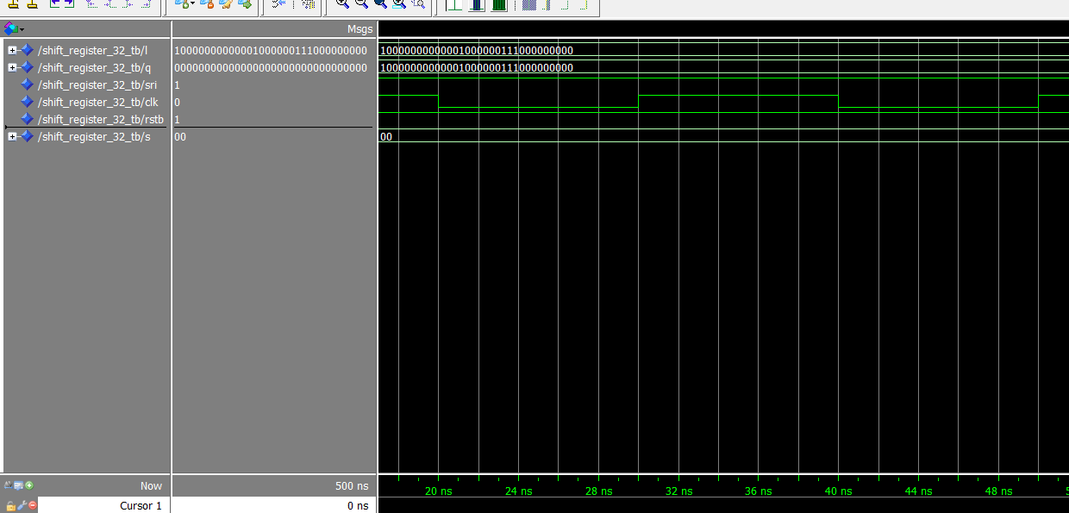

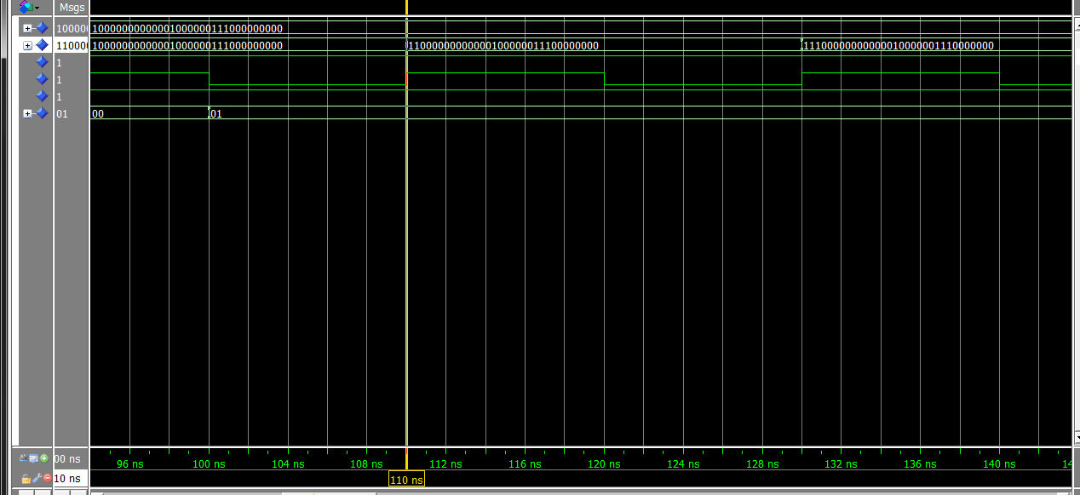

    - 6 bit Binary counter (from 63 count down to 0)

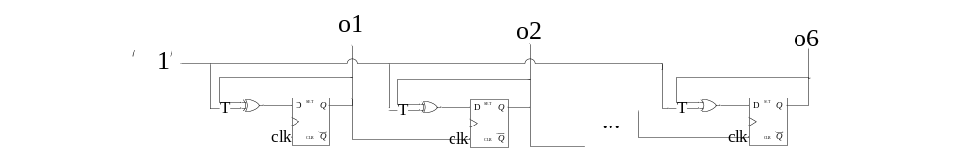code
entity binary_counter_64 is
port(clk : in bit;
o : out bit_vector(5 downto 0));
end entity;

architecture struct of binary_counter_64 is
component tff is
port( t, clk, rstb : in bit;
q, qb : out bit);
end component;

for all: tff use entity work.tff(struct);
signal im : bit_vector (5 downto 0);
signal one : bit := '1';
signal rstb : bit := '1';

begin
c1: tff port map(one,clk,rstb,im(0));
c2: tff port map(one,im(0),rstb,im(1));
c3: tff port map(one,im(1),rstb,im(2));
c4: tff port map(one,im(2),rstb,im(3));
c5: tff port map(one,im(3),rstb,im(4));
c6: tff port map(one,im(4),rstb,im(5));

o <= im;
end struct;

testbench
entity binary_counter_64_tb is
end entity;

architecture io of binary_counter_64_tb is
component binary_counter_64 is
port(clk : in bit;
o : out bit_vector(5 downto 0));
end component;

for all: binary_counter_64 use entity work.binary_counter_64(struct);

signal o : bit_vector(5 downto 0);
signal clk : bit;

begin
c1: binary_counter_64 port map(clk,o);

clk <= not clk after 5ns;

end io;

waveform
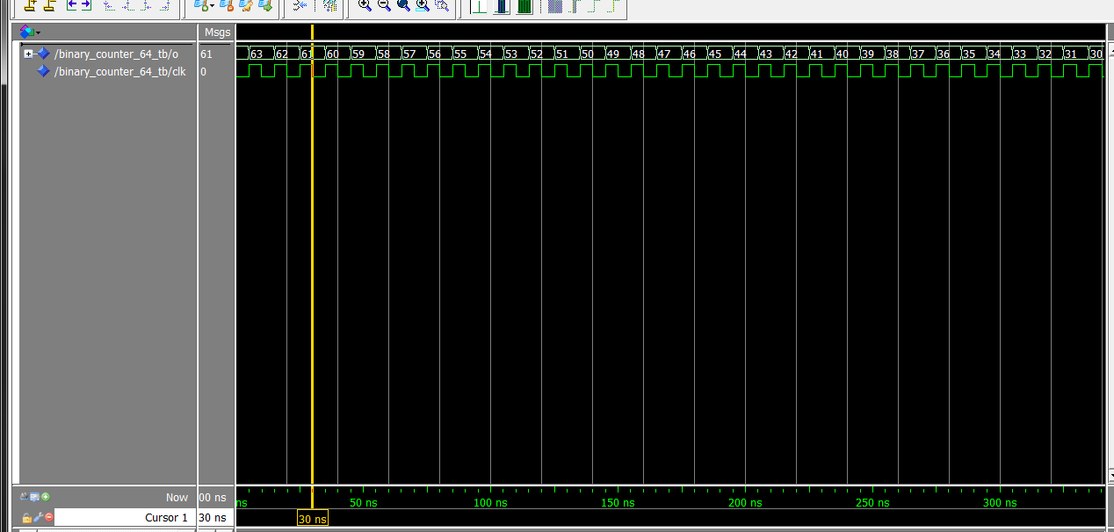
    - Cmp1
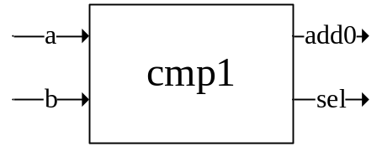
Truth table
a | b | Add0 | sel
0 | 0 | 0 | 0
0 | 1 | 1 | 1
1 | 0 | 1 | 0
1 | 1 | 0 | 0

Add0 = a xor b
Sel = a’b
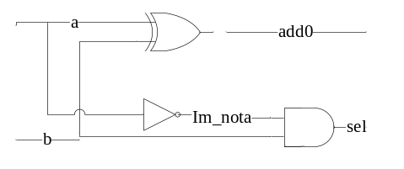
Code
entity cmp1 is
port (a,b :in bit;
add0, sel : out bit);
end entity;

architecture struct of cmp1 is
component xor_gate is
port(a,b: in bit;
c: out bit);
end component;

component not_gate is
port(a: in bit;
c: out bit);
end component;

component and2 is
port(a, b : in bit;
c : out bit);
end component;

for all: xor_gate use entity work.xor_gate(dataflow);
for all: not_gate use entity work.not_gate(dataflow);
for all: and2 use entity work.and2(dataflow);

signal not_a : bit;

begin
c1: xor_gate port map(a,b,add0);
c2: not_gate port map(a,not_a);
c3: and2 port map(not_a,b,sel);
end struct;

testbench
entity cmp1_tb is
end entity;

architecture io of cmp1_tb is
component cmp1 is
port (a,b :in bit;
add0, sel : out bit);
end component;

for all: cmp1 use entity work.cmp1(struct);

signal a,b,add0,sel : bit;

begin
c1: cmp1 port map(a,b,add0,sel);

a <= not a after 10ns;
b <= not b after 23ns;
end io;

waveform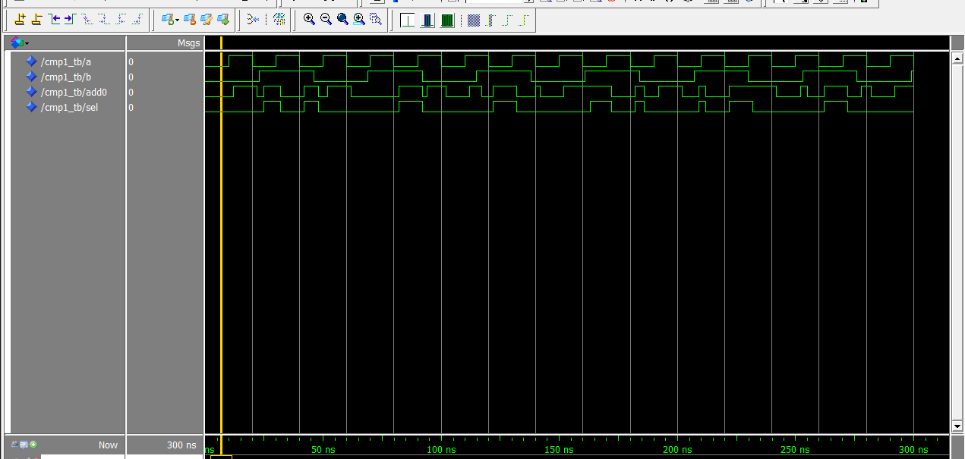
    - Cmp2
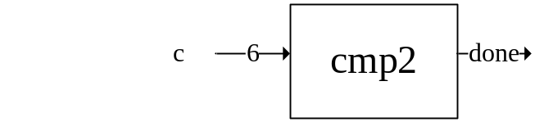

Truth table
C5 | C4 | C3 | C2 | C1 | C0 | done
0 | 0 | 0 | 0 | 0 | 0 | 1
0 | 0 | 0 | 0 | 0 | 1 | 0
… | … | … | … | … | … | …

Done = c5’c4’c3’c2’c1’c0’
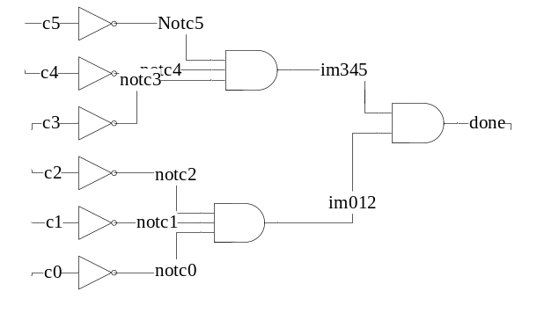
Code
entity cmp2 is
port(c : in bit_vector;
done : out bit);
end entity;

architecture struct of cmp2 is
component and2 is
port(a, b : in bit;
c : out bit);
end component;

component and3_gate is
port(a, b, c: in bit;
d : out bit);
end component;

component not_gate is
port(a: in bit;
c: out bit);
end component;

for all: and2 use entity work.and2(dataflow);
for all: and3_gate use entity work.and3_gate(dataflow);

signal im_345, im_210 : bit;
signal imnotc5,imnotc4,imnotc3,imnotc2,imnotc1,imnotc0 : bit;

begin
c5: not_gate port map(c(5),imnotc5);
c4: not_gate port map(c(4),imnotc4);
c3: not_gate port map(c(3),imnotc3);
c2: not_gate port map(c(2),imnotc2);
c1: not_gate port map(c(1),imnotc1);
c0: not_gate port map(c(0),imnotc0);

c6: and3_gate port map(imnotc5,imnotc4,imnotc3,im_345);
c7: and3_gate port map(imnotc2,imnotc1,imnotc0,im_210);

c8: and2 port map(im_210,im_345,done);
end struct;

testbench
entity cmp2_tb is
end entity;

architecture io of cmp2_tb is
component cmp2 is
port(c : in bit_vector (5 downto 0);
done : out bit);
end component;

for all: cmp2 use entity work.cmp2(struct);

signal c : bit_vector(5 downto 0);
signal done : bit;

begin
c1: cmp2 port map(c,done);

c <= "000000","000100" after 50ns,"100100" after 100ns,"000000" after 150ns, "101010" after 200ns;
end io;

waveform
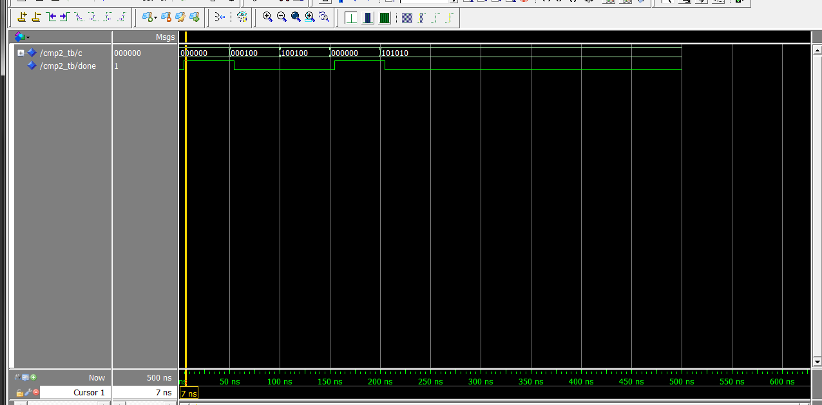
- controller(dataflow)
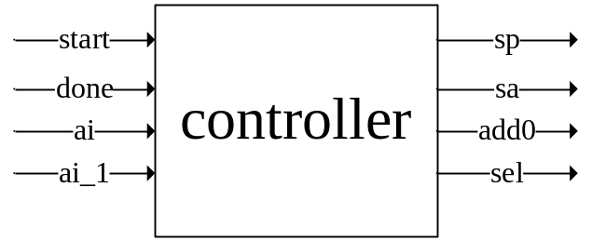
States | q
S0 = | 0000001
S1 = | 0000010
S2 = | 0000100
S3 = | 0001000
S4 = | 0010000
S5 = | 0100000
S6 = | 1000000
S7 = | 0000000
D0 = s6*start + s7*start
D1 = s0*done’
D2 = s1(ai_1*ai+ai_1’ai’) + s5*done’ (ai_1*ai+ai_1’ai’)
D3 = s1*ai_1’*ai + s5*done’* ai_1’*ai
D4 = s1*ai_1*ai’ + s5* done’*ai_1*ai’
D5 = s2 + s3 +s4
D6 = s5*done

S1p = s2 + s3 + s4 + s6
S0p = s2 + s3 + s4 + s5 + s6
S1a = s1 + s2 + s3 + s4 + s6
S0a = s1 + s2 + s3 + s4 + s5 + s6
Add0 = s3 + s4
Sel = s3

Code

library ieee;
use ieee.std_logic_1164.all;

entity cfbm is
port (start, done, ai, ai_1, clk, rstb : in bit;
sp, sa : out bit_vector(1 downto 0);
add0, sel : out bit);
end entity;

architecture dataflow of cfbm is
component and2 is
port(a, b : in bit;
c : out bit);
end component;

component and3_gate is
port(a, b, c : in bit;
d : out bit);
end component;

component or2 is
port(a,b : in bit;
c : out bit);
end component;

component or3_gate is
port(a,b,c : in bit;
d : out bit);
end component;

component dff is
port( d,clk,rstb : in bit;
q,not_q : out bit);
end component;

component not_gate is
port(a: in bit;
c: out bit);
end component;

for all: and2 use entity work.and2(dataflow);
for all: and3_gate use entity work.and3_gate(dataflow);
for all: or2 use entity work.or2(dataflow);
for all: or3_gate use entity work.or3_gate(dataflow);

signal im_qs : bit_vector(6 downto 0) := "0000001";--begin at state s0(load all data);
signal im_ds : bit_vector(6 downto 0) := "0000001";
signal im_not_done, im_not_ai, im_not_ai_1 : bit;
signal im : bit_vector(20 downto 0);

-- signal s0: bit_vector(6 downto 0) := "0000001";
-- signal s1: bit_vector(6 downto 0) := "0000010";
-- signal s2: bit_vector(6 downto 0) := "0000100";
-- signal s3: bit_vector(6 downto 0) := "0001000";
-- signal s4: bit_vector(6 downto 0) := "0010000";
-- signal s5: bit_vector(6 downto 0) := "0100000";
-- signal s6: bit_vector(6 downto 0) := "1000000";

signal s0,s1,s2,s3,s4,s5,s6,s7,init,notinit,k: bit;

begin
------------------------decoding-------------------------------
s7 <= ((((not im_qs(0)) and (not im_qs(1)))and ((not im_qs(2)) and (not im_qs(3)))) and ((not im_qs(4)) and (not im_qs(5)))) and (not im_qs(6));
s6 <= ((((not im_qs(0)) and (not im_qs(1)))and ((not im_qs(2)) and (not im_qs(3)))) and ((not im_qs(4)) and (not im_qs(5)))) and im_qs(6);
s5 <= ((((not im_qs(0)) and (not im_qs(1))) and ((not im_qs(2)) and (not im_qs(3))))and ((not im_qs(4)) and im_qs(5))) and (not im_qs(6));
s4 <= ((((not im_qs(0)) and (not im_qs(1))) and ((not im_qs(2)) and (not im_qs(3))))and (im_qs(4) and (not im_qs(5)))) and (not im_qs(6));
s3 <= ((((not im_qs(0)) and (not im_qs(1))) and ((not im_qs(2)) and im_qs(3))) and ((not im_qs(4)) and (not im_qs(5)))) and (not im_qs(6));
s2 <= ((((not im_qs(0)) and (not im_qs(1))) and (im_qs(2) and (not im_qs(3)))) and ((not im_qs(4)) and (not im_qs(5)))) and (not im_qs(6));
s1 <= ((((not im_qs(0))and im_qs(1)) and ((not im_qs(2)) and (not im_qs(3)))) and ((not im_qs(4)) and (not im_qs(5)))) and (not im_qs(6));
s0 <= (((im_qs(0) and (not im_qs(1)))and ((not im_qs(2)) and (not im_qs(3)))) and ((not im_qs(4)) and (not im_qs(5)))) and (not im_qs(6));
--d0
c1: and2 port map(s6,start,im_ds(0));
c0: and2 port map(s7,start,init);
c: or2 port map(init,im_ds(0),k);
dff_1: dff port map(k,clk,rstb,im_qs(0));
--d1
c2: not_gate port map(done, im_not_done);
c3: and2 port map(s0,im_not_done,im_ds(1));
dff_2: dff port map(im_ds(1),clk,rstb,im_qs(1));
--d2
c4: not_gate port map(ai, im_not_ai);
c5: not_gate port map(ai_1, im_not_ai_1);
c6: and2 port map(ai,ai_1,im(0));
c7: and2 port map(im_not_ai,im_not_ai_1,im(1));
c8: or2 port map(im(0),im(1),im(2));
c9: and3_gate port map(im(2),s5,im_not_done,im(3));
c10:and2 port map(s1,im(2),im(4));
c11:or2 port map(im(3),im(4),im_ds(2));
dff_3: dff port map(im_ds(2),clk,rstb,im_qs(2));
--d3
c12:and3_gate port map(s1,im_not_ai_1,ai,im(5));
c13:and2 port map(s5,im_not_done, im(6));
c14:and2 port map(im_not_ai_1,ai, im(7));
c15:and2 port map(im(6),im(7),im(8));
c16:or2 port map(im(8),im(5),im_ds(3));
dff_4: dff port map(im_ds(3),clk,rstb,im_qs(3));
--d4
c17:and3_gate port map(s1,ai_1,im_not_ai,im(9));
c18:and2 port map(ai_1,im_not_ai, im(10));
c19:and2 port map(im(6),im(10),im(11));
c20:or2 port map(im(9),im(11),im_ds(4));
dff_5: dff port map(im_ds(4),clk,rstb,im_qs(4));
--d5
c21:or3_gate port map(s2,s3,s4,im_ds(5));
dff_6: dff port map(im_ds(5),clk,rstb,im_qs(5));
--d6
c22:and2 port map(s5,done,im_ds(6));
dff_7: dff port map(im_ds(6),clk,rstb,im_qs(6));

-----------------------------------output------------------------------------
--s1p
c23:or2 port map(s2,s3,im(12));
c24:or2 port map(s4,s6,im(13));
c25:or2 port map(im(12),im(13),sp(1));
--s0p
c26:or3_gate port map(im(12),im(13),s5,sp(0));
--s1a
c27:or3_gate port map(im(12),im(13),s1,sa(1));
--s0a
c28:or2 port map(s1,s5,im(14));
c29:or3_gate port map(im(12),im(13),im(14),sa(0));
--add0
c30:or2 port map(s3,s4,add0);
--sel
sel <= s3;

end dataflow;

Testbench
entity controller_for_booth_multiplier_tb is
end entity;

architecture io of controller_for_booth_multiplier_tb is
--component controller_for_booth_multiplier is
component cfbm is
port (start, done, ai, ai_1, clk, rstb : in bit;
sp, sa : out bit_vector(1 downto 0);
add0, sel : out bit);
end component;

--for all: controller_for_booth_multiplier use entity work.controller_for_booth_multiplier(behaviour);
for all: cfbm use entity work.cfbm(dataflow);

signal start, done, ai, ai_1, clk, rstb : bit;
signal sp, sa : bit_vector(1 downto 0);
signal add0, sel : bit;

begin
-- c1: controller_for_booth_multiplier port map (start, done, ai, ai_1, clk, rstb, sp, sa, add0, sel);
c1: cfbm port map (start, done, ai, ai_1, clk, rstb, sp, sa, add0, sel);

start <= '1','0' after 40ns, '1' after 550ns;
done <= '0', '1' after 500ns,'0' after 736ns;
ai <= '1','0' after 100ns,'1' after 250ns, '0' after 470ns;
ai_1 <= '0','1' after 100ns, '1' after 250ns, '0'after 470ns;
clk <= not clk after 30ns;
rstb <= '1';

end io;

waveform
